Assignment 2- Case Study (8995-G level Task)

Stage 5 Lab Activities

Refactoring SmartCare into a Layered Architecture
HUMAN ANALYSIS -> REFACTOR -> AI REVIEW -> VERIFY | 1 hour

A - Inspect SmartCare v0.4
- Domain: InvalidStatus, TransitionError, AppointmentStatus, Patient, Practitioner, Appointment. These are the business rules and entities themselves.
- Workflow (coordination): appt1.book(appointments) followed by appointments.append inside __main__. This runs the booking rule, it’s a manual sequence not an owned operation
- Data-access: appointments: list[Appointment] = [] and its .append() calls (lines 281, 311). This is standing in as storage, with no real persistence layer behind it.
- Presentation: every print(...) call, formatting and displaying the demo output.

B - Propose Architecture
Draw Presentation -> Service -> Domain, with Service using a Repository abstraction and Persistence implementing it.
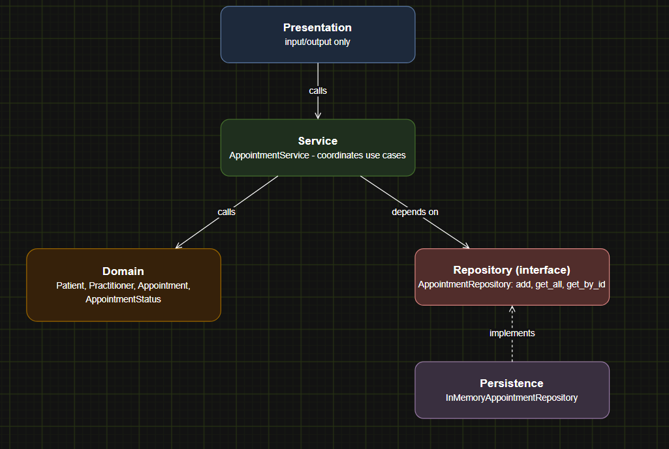

C - Create Package Structure
- domain/ will contain patient.py, practitioner.py and appointment.py, holding the Patient, Practitioner, Appointment, AppointmentStatus and InvalidStatusTransitionError classes.
- repositories/ will contain appointment_repository.py, holding only the AppointmentRepository interface.
- persistence/ will contain in_memory_appointment_repository.py, holding the concrete implementation of that interface.
- services/ will contain appointment_service.py, holding the AppointmentService class.
- presentation/ will contain demo.py, the entry point that replaces the previous __main__ block

E - Repository Abstraction

add(appointment: Appointment) -> None is needed because book() must persist a newly confirmed appointment somewhere.

get_all() -> list[Appointment] is needed because check_conflict() (called from both book() and reschedule()) requires the full list of existing appointments to check against.

get_by_id(appointment_id: str) -> Appointment | None is needed to support "find appointment by ID," a responsibility already named earlier.

F - AI Architecture Review

Dependency direction: AppointmentService must import the AppointmentRepository interface, not InMemoryAppointmentRepository directly, or it violates DIP.

Misplaced responsibility: AppointmentService must not re-check conflicts itself; it should call Appointment.check_conflict(), or the rule gets duplicated outside the domain layer.

Simplest justified improvement: pass the repository into AppointmentService's constructor (plain manual injection, no framework), so tests can substitute a fake repository.

G - Refactor and Verify

- AppointmentService.__init__ takes an AppointmentRepository-typed parameter, never imports InMemoryAppointmentRepository directly → fixes the DIP violation.
- AppointmentService.book_appointment() calls appointment.check_conflict() and appointment.book(). It does not re-implement any clash-detection logic itself and fixes the misplaced responsibility.
- The repository is passed into AppointmentService's constructor by the caller (manual injection) then applies the simplest justified improvement, no framework added

H – Reflection

I accepted AppoointmentService receive its repository through the constructor manual injection. This is a good practice and it lets fake repository to be substituted for testing
I modified the dependency direction flag (service depending on a repository class instead of the interface) was accepted as a finding.
I rejected the microservice, an event bus and six separate interfaces were all rejected. SmartCare is a single small application with simple flow.

Suggested AI prompt
Act as a software architecture reviewer. Review this small SmartCare Python system against separation of concerns, cohesion, coupling and introductory SOLID principles. Identify concrete layer violations and dependency risks. Prefer the simplest refactoring that solves an observed problem. Do not introduce frameworks, microservices or patterns unless current requirements justify them.

